“The life of faith is a journey” - Pope Francis  Mass times on Sunday to assist with Faith Formation- we are pleased to announce that we have three masses that will assist families before and after Sunday Program 9am at both Holy Family and St. Ann and 11:30am at Sacred Heart. Along with our 4pm Sacred Heart and 4:30pm St. Alphonsus on Saturday.  Program Fees Fees are designed cover the cost of materials and supplies. Financial assistance available. Checks can be made out to Holy Family and sent to the Faith Formation Office at 85 North St. Auburn, NY 13021. Assistance is available.  Questions?Contact Barbara Quinn at the address above, email: Barbara.Quinn@dor.org org 315.252.9576 ext. 316. | Faith Formation Office, 85 North St., Auburn, NY 13031 | Catholic Community of St. Ann, Sacred Heart, St. Alphonsus and Holy Family of Auburn, NY  - 2023-24 Faith Formation  - Programs  - Father Stephen Karani, Pastor
Sacramental Preparation for First Penance and First Eucharist  Children aged 7 and above who are enrolled in Catholic schools or Faith Formation programs are eligible to enter the sacramental prep programs.  There is no cost to the program and session for First Penance will begin in January, First Eucharist in March with First Penance in April, 2024 and First Eucharist in May 2024  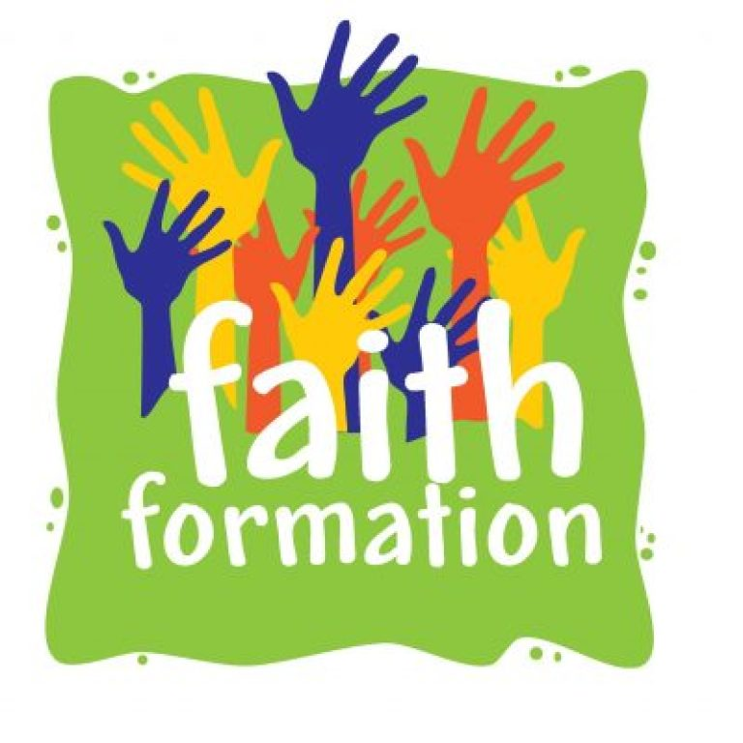 | Catholic Community Sunday Program K-6 at Sacred Heart will be offered in two sessions 10:30am to 11:30am.  Session I will run from September 17- December 17, 2023  Session II from January 21 to May 5, 2024. (No class Easter Sunday).  The program provides appropriate grade level instruction by certified Catechists.  The Program cost is $35 ($65 for two or more children) for materials and supplies.  Independent Study K-8  This program is designed for families who want to work independently with their children and moderate their own instructional pace.  Materials can either be self-selected (with approval at no cost) or use of our current program materials at a cost of $35 ($65 for two or more children).  This program is designed for families who want to work independently and moderate their own instructional pace.  Materials can be either self- selected (with approval at no cost), utilization of our current program materials or using lessons designed by our catechists. These three options allow families to regulate the program according to their needs. | Youth Group Grades 7 and Up  Youth group offers teens the instruction to focus on Catholic Social Justice projects and further promotes discipleship. The Program is offered once a month on Sunday nights from 5:30-7pm beginning October 8. Dates will be sent to enrolled families. The cost is $25 per participant.  “Faith Formation seeks to help people: grow in their relationship with God for the whole of life.'” -Vibrant Faith  Confirmation Grades 8 and Up  Confirmation is a two- year program offered to candidates starting in 8th grade and above. Classes begin September 2023 for Year 1 Candidates. The cost is $25 per year, per candidate.

