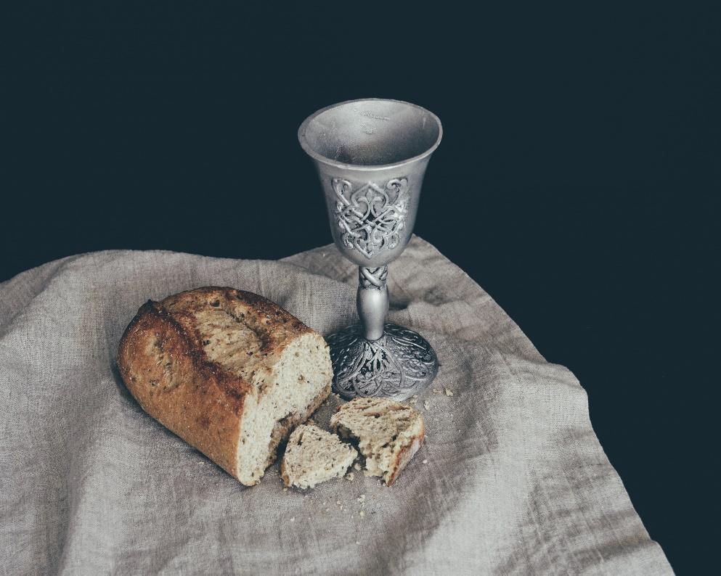
This will be the future home of further information on the Sacraments

