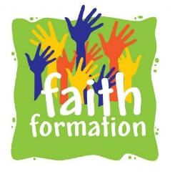
Catholic Community of St. Ann, Sacred Heart, St. Alphonsus and Holy Family
Faith Formation Office, 85 North St. Auburn, NY 13021
Barbara Quinn, Coordinator of Faith Formation
Email: Barbara.Quinn@dor.org Telephone: 315. 252.9576 ext. 316.

August,2023

Dear Parents and Guardians:

Our records indicate that your child is eligible to join our 2023-24 Confirmation Class.
Confirmation is a two year program in the Diocese of Rochester. It requires that your child commit to attendance at class, completion of an annual service project, and annual attendance at a Confirmation retreat. We have enclosed a brochure outlining the program and invite you and your child to consider making a commitment to participate in the Confirmation program.

Our program begins with a mandatory Parent/Candidate meeting on September 24th from 1pm to 2pm at Sacred Heart. 2023-2024 Meetings will be Sundays from 5:30-7pm at Sacred Heart. Our sessions are tentatively scheduled for 10/15, 11/5, Retreat on Saturday 12/3, 2023 and 1/7, 2/11, 3/10, 4/7 and 5/5/2024.

If you and your child would like to participate in the program, please complete the registration form and return it to the address above. It can be dropped off at the Holy Family/St. Alphonsus Rectory or mailed to the address above. The fee is $30.00 per candidate and checks can be made payable to Holy Family Church. If you have any questions regarding the program, please feel free to call the rectory and leave a message at ext. 316 or email me at Barbara.Quinn@dor.org.

We ask that you register by September 15 to ensure we have your email and information for the meeting. We hope to see you at our meeting on the 24th.
God Bless,
Barbara B. Quinn, Coordinator of Faith Formation

